SSBC “Optimal Connectivity Guide"- By Dracobat10, Ultimadux

When it comes to connecting with the “majority" of people that play SSBC online, you'd run into a bunch of struggles like “which person hosts, how am I getting the ip, what can boost my connection”, that stuff. I'm laying as much of that to rest as possible with this guide here

First, “Everyone & about everyone” uses the Logmein Hamachi client. Don't come complaining that it doesn't work or be stubborn on not using it. Unless you know how to “port forward", this is the most ***widespread client*** to use. It works by making a virtual network, with an ip that's different to your real one, so you could stay slightly more safe on sharing it or connecting to people needing an address. Begin by “*making an account* on the download site, to then *download* & install the client".



***Be sure you install it in the right folder, like *Program Files 86* or so, else it won't function correctly when active.*** (Windows installs programs in said folder by default unless you change it during installation.)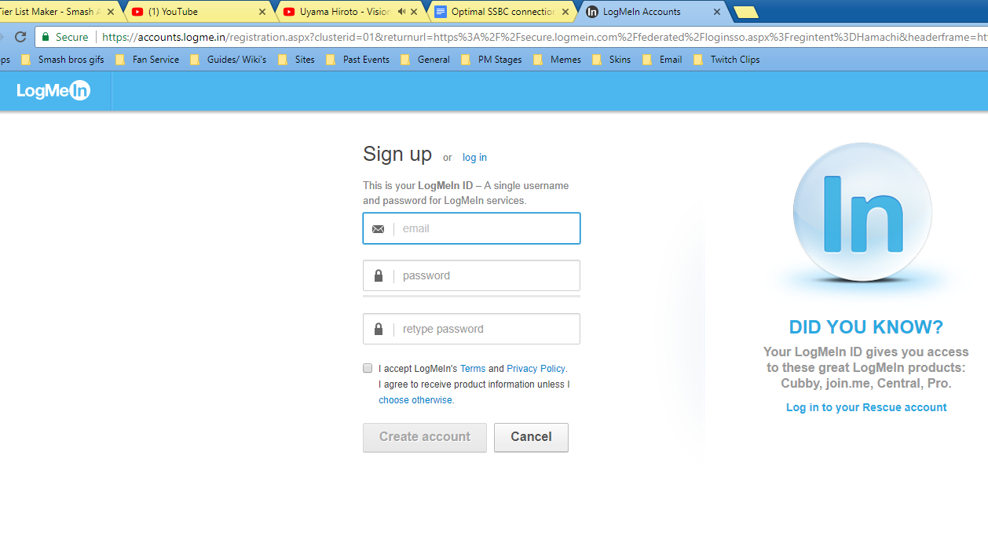

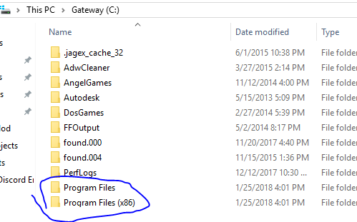

***(*OPTIONAL*)*** As a precaution if you don’t trust the program safety, you can head into control panel & find the network & internet tab, or network adapter settings/ network connections (may vary from OS) it should pop up with a list of different network adapters, the installed Hamachi one likely having its own with the same name. Right click it, head into properties, and uncheck “File & Printer Sharing”, which should stop any possible attack if the chance happens.)

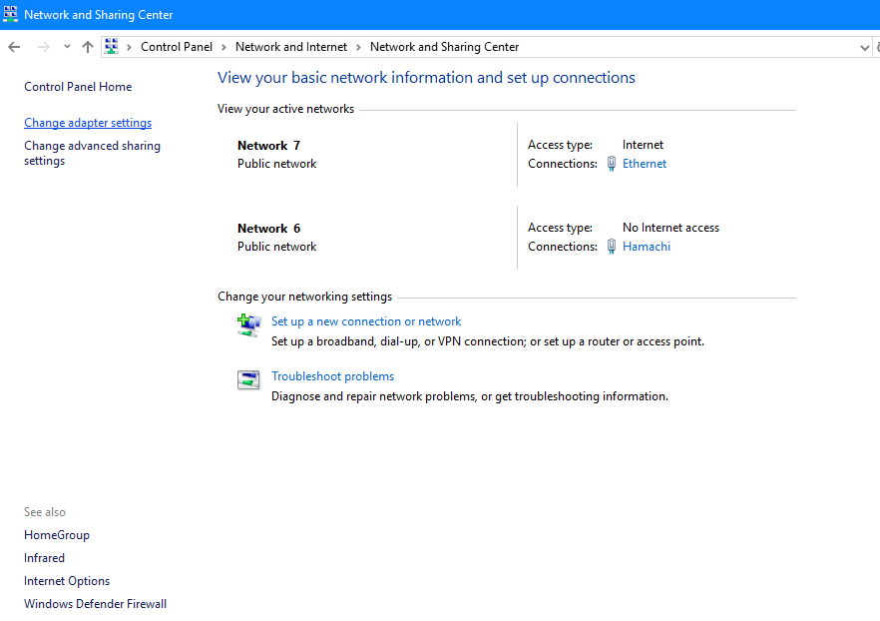

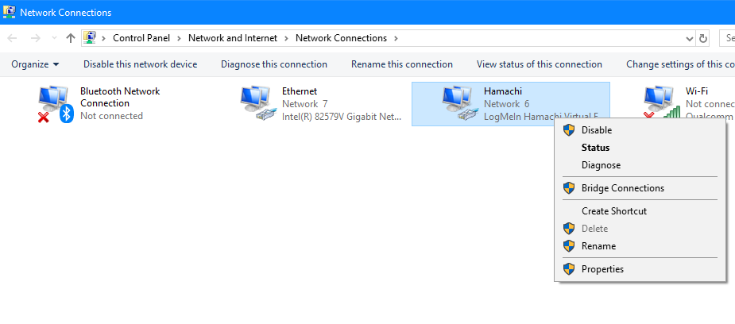

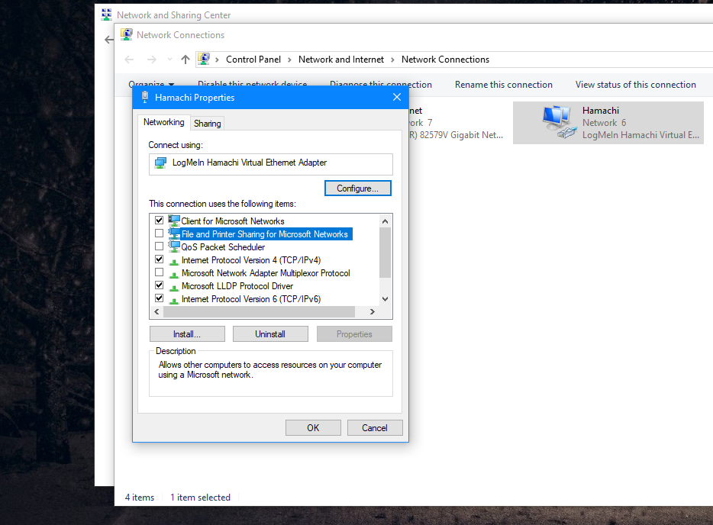

Once installed, you can open up the program & start setting up by clicking the *“System” tab & then “Preferences”.* You’ll be on the *“Status”* Menu, which allows you to link your account and *change your name* just under “*client”* , which is **recommended**. You will be seen as your Official PC Name like “GatewayDX780” or “Laptop5100”, whatever your computer model name is if you don’t change it. Next, you click the *“Settings”* menu below the other two. Under *“Peer Connections”* set the *“Encryption”* of both options to *“any”*. From there, you click the blue “Advanced Settings” option, which will give you a list of several things. Scroll down to find text that say “Custom format, $NICK, $VIP. You’ll want to edit it by clicking it, then clicking “set”. Add in the text in the same fashion, “$PING”. This will allow you to see the ping from people that connect to you, giving an idea of how good or bad the connection may be between you two. Ranges below 40ms are good or great connections, though numbers above 65ms to 100ms are laggy or really delayed. *(****Ethernet*** *cables are highly recommended over Wi-Fi for the best overall/stable connection)*

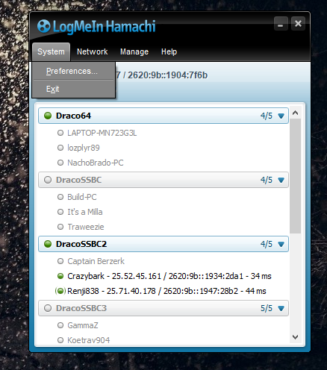

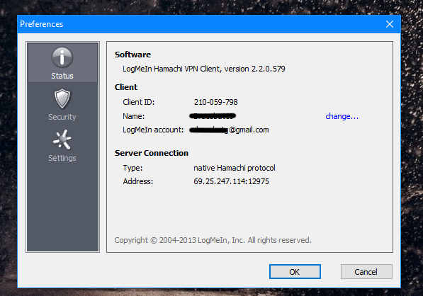

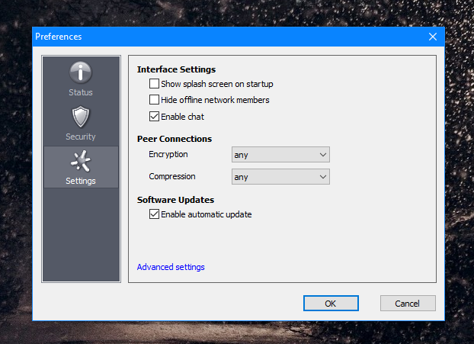

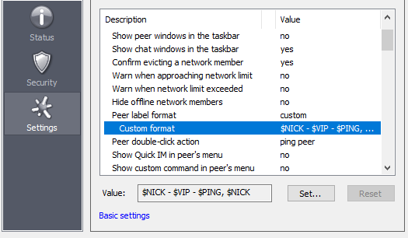

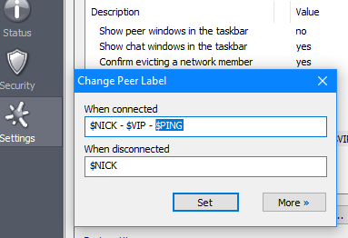

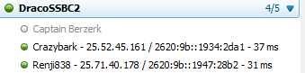

With your Hamachi Name, Encryption and Ping now set, you can now join the networks of others or create your own, hitting the *“Network Tab”* with said options. When joining a network, enter the exact mentioned ID and password as stated (some servers may not have passwords) and you’ll be in. When creating one though, you can set it to your liking, just make the name and password short and simple so it’s easy to type in, like “SSB” and the password “smash”

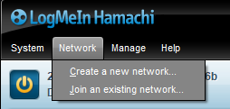

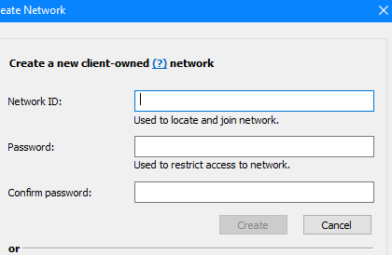

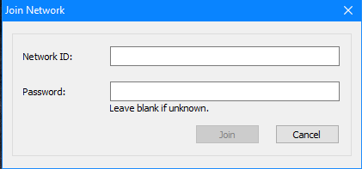

With the network up, you can save time by removing the password if you right click it & hit *“Set Access”*. Just uncheck the *“Require Password”* box. Keep in mind that **no two networks can have the same name**, so you’ll have to name it something no one has used to create the network. Alongside are also extra options for server management, such as *“Go Offline”* turning that specific server out if you don’t want people joining unwanted, or *“Evict”* if you right click a person in your server to “kick ‘em out” for extra space, at least if they don’t play often or consistently and you want to be organized. (& *“Delete Network”* for the purposes you’d delete it for.)

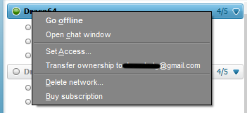

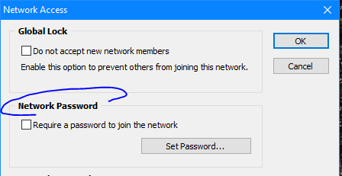

Once you’re in, you’ll see the person’s name and a green circle in front, and their ping with the added value. To join them, simply right click their name and *“copy the ipv4”*. Paste it into the Crusade *“Join”* menu online and you should connect successfully!

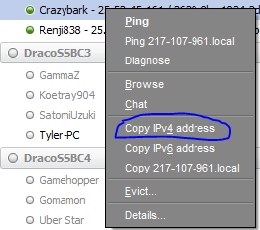

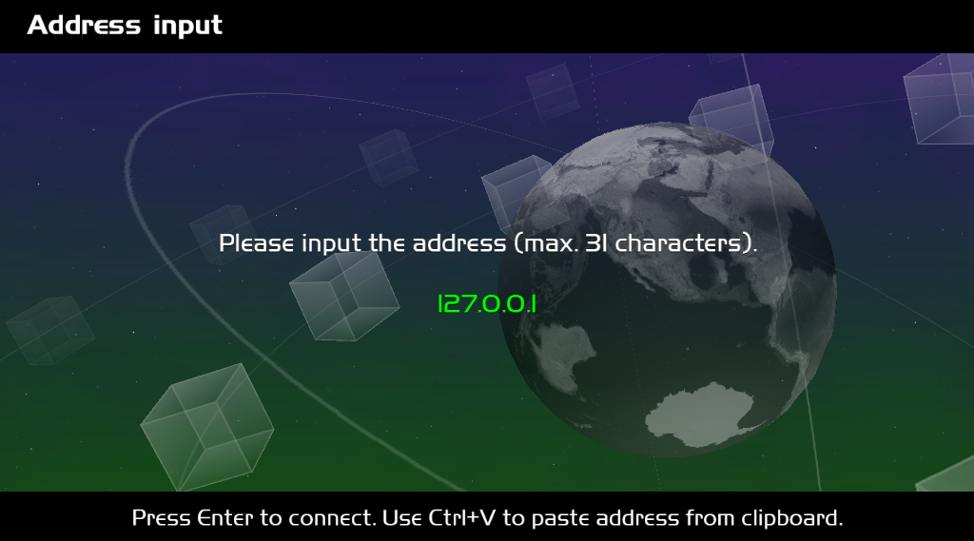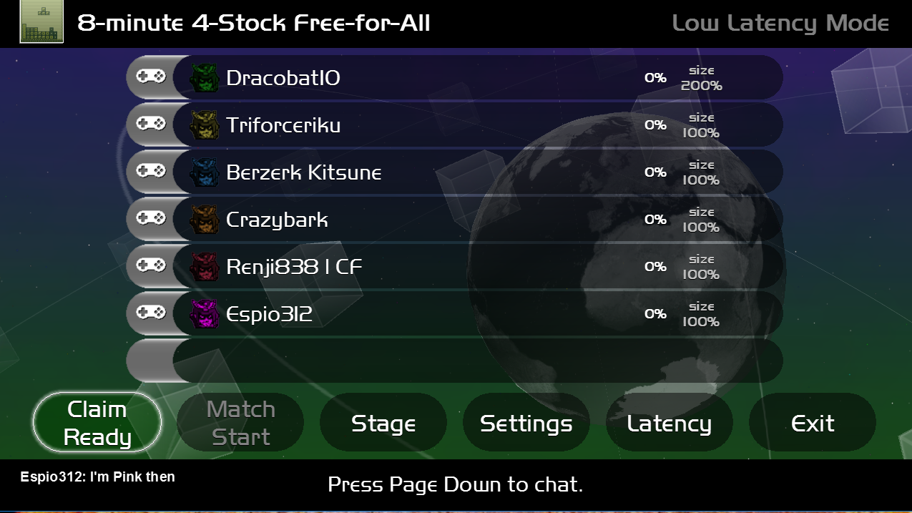

***REMINDER-*** Crusade will likely not connect or Hamachi may be blocked by *Windows Firewall.* When you first open or use both online, there may be a *security prompt* to allow it through, make sure to **check** it on *both “private” and “public” networks* for both apps. If you skipped that on accident, then you’ll have to do it *manually,* which is really simple. Go to *“Windows Firewall”* by typing it in the *“Start Search” (Windows 10)* or through “*Control Panel”*, and click *“Allow an app through firewall”*. It will bring up a large *“checklist”*, which you’ll have to find the apps under their **“true names”**. They can be *different* for each person or sometimes may not show. If such, then you’ll have to manually add the app into the list with the option *“Allow another app”*. Find the program application’s location and set it. Once you find the apps, *check them under both network boxes* as mentioned. You should be good from there.